Eckart Boehmer
Director of the Kaspar Hauser Festival in Ansbach, Germany
Co-founder of the Kaspar Hauser Research Circle
will give two talks “Kaspar Hauser and Parzival, Part I and II”

Richard Steel
Director of Karl Konig Institute for Art, Science and Social Life
will give the opening talk “Kaspar Hauser and the Grail”

Glen Williamson
Actor will perform his Kaspar Hauser Play,
“Kaspar Hauser: The Open Secret of the Foumdiling Primce”

Penelope Baring
Teacher in Camphill Academy and the organizer of the Kaspar Hauser Festival in the west coast will give a talk
“Mani and the Egyptian Mysteries in Relation to Kaspar Hauser”

Alan Thewless
Teacher and Astrosopher will give a talk
“The Cosmic Aspect in Relation to the Life of Kaspar Hauser”

Registration fee $90 for the full festival-$10 per talk/performance

The Kaspar Hauser Research Circle
www.kaspar-hauser.net/en/index.html
For registration/more information about the festival, please contact
Takeshi Suesada
takeshi@triform.org
Or register/make payment through the website below
The Kaspar Hauser Festival in the Columbia County, NY
www.kasparhauserfestival.net

Kaspar Hauser Festival
in Columbia County, New York
Kaspar Hauser and the Grail

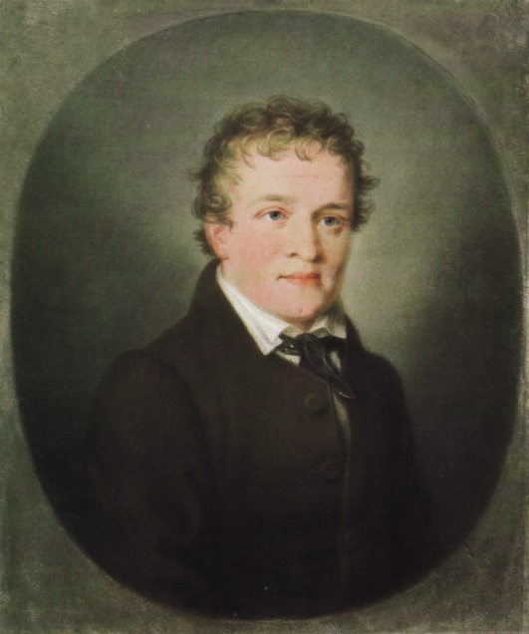

October 31 (Thursday)-November 3 (Sunday)

Hosted by Camphill Village Copake, Triform Camphill Community, Camphill Hudson, Camphill Ghent and
The Kaspar Hauser Research Circle (Berlin,Germany)

Kaspar Hauser and the Grail October 31-November 3, 2019

October 31 (Thursday)  Halloween | November 1 (Friday)  All Saint’s Day | November 2 (Saturday)  All Soul’s Day | November 3 (Sunday)
Venue: Camphill Ghent | Venue: Camphill Village Copake | Venue - Camphill Village Copake | Venue: Camphill Ghent
 | 9:00 am Opening - tone of the day/eurythmy  Formal Opening and Welcome  Talk by Alan Thewless,  “The Cosmic Aspects in Relation to the Life of Kaspar Hauser-An Astrosophical Research”  Open to the public ($10 admission)  10:30 am Tea Break  11:00 am Artistic Workshops  Acting (Glen Williamson)  Poetry (Richard/ Stephen Steen)  Eurythmy (Orin & Michal Bar-Shalom) | 9:00 am Tone of the day/eurythmy  Talk by Eckart Boehmer,  “Kaspar Hauser and Parzival Part I”  Open to the public ($10 admission)  10:30 am Tea Break  11 am Artistic Workshops  Acting (Glen Williamson)  Poetry (Richard/ Stephen Steen)  Eurythmy (Orin & Michal Bar-Shalom) | 9:00 am Sharing from the artistic workshops  News/Updates from the Kaspar Hauser Research Circle  10:30 am Tea Break  11:00 am Concluding plenum  (No lunch offered)
4:30pm-5:30pm  Registration at Camphill Ghent | 12:30 pm Lunch in Camphill Village Copake Cafe  2:00 pm Artistic contribution  Talk by Penelope Baring,  “Mani and the Egyptian Mysteries in relation to Kaspar Hauser”  Open to the public ($10 admission)  3:30 pm Tea Break  4:00 pm Small Group Conversations | 12:30 pm Lunch in Camphill Village Copake Cafe  2:00 pm Artistic contribution  Talk by Eckart Boehmer,  “Kaspar Hauser and Parzival Part II”  Open to the public ($10 admission)  3:30 pm Tea Break  4:00 pm Small Group Conversations  (All participants drive to Triform afterwards for supper and the All Soul’s Day evening)
6:00 pm Supper in town (at leisure)  7:30 pm Artistic contribution  Introduction to the theme  “Kaspar Hauser and the Grail” Opening talk by Richard Steel  Open to the public ($10 admission) | 6:00 pm Supper in Camphill Village Copake Cafe  7:30 pm A Play by Glen Williamson, “Kaspar Hauser: The Open Secret of the Foundling Prince” Open to the public ($10 admission) | 6;00 pm Supper at the Phoenix Center in Triform  7:30 pm All Soul’s Day Evening in Triform (in Falcon Hall)  Karl Konig’s “ A Christmas Story” in Puppet Theater by Camphill Academy students and volunteers  (Donation suggested-open event but limited extra seating)
* Lectures and play open to non-registered attendees. $10/lecture or play

